

SAVEETHA SCHOOL OF ENGINEERING

SAVEETHA INSTITUTE OF MEDICAL AND
TECHNICAL SCIENCES

DEPARTMENT OF COMPUTER SCIENCE AND ENGINEERING

LIST OF EXPERIMENTS

COURSE CODE : CSA4001
COURSE NAME : MANAGEMENT INFORMATION SYSTEM

6 Draw a Use case diagram to model for a quiz system. A user can request a quiz for the system. The system picks a set of questions from its database, and composes them together to make a quiz. It rates the user’s answers and gives hints if the user requests it. In addition to users, we also have helpers who provide questions and hints. And also, administrators who must certify questions to make sure they are not too trivial, and that they are correct

AIM:
To design a Use Case Diagram for a Quiz System, illustrating the interactions between Users, Helpers, and Administrators in quiz creation and evaluation.

PROCEDURE:
• User Interactions
- Users request a quiz.
- The system generates a quiz by selecting questions from the database.
- Users receive ratings for their answers.
- Users can request hints during the quiz.
• Helper Interactions
- Helpers submit questions and hints for the quiz system.
• Administrator Responsibilities
- Administrators review and approve submitted questions to ensure correctness and difficulty balance.

OBSERVATION:

USECASE DIAGRAM:
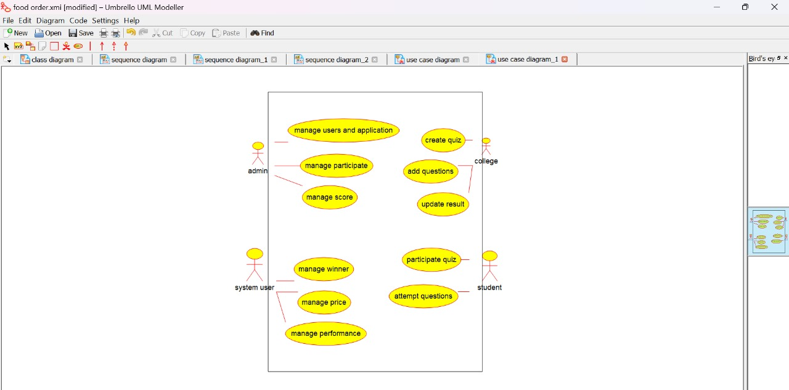

CLASS DIAGRAM:
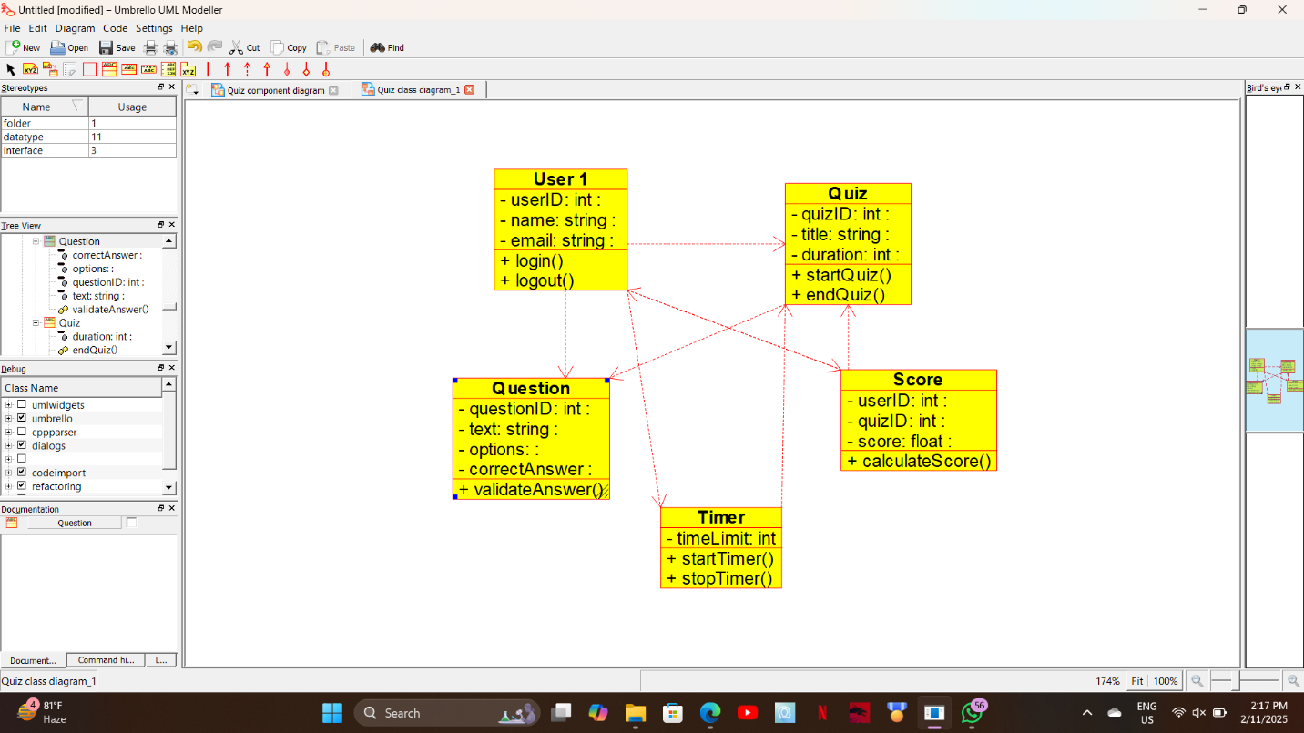

ACTIVITY DIAGRAM:
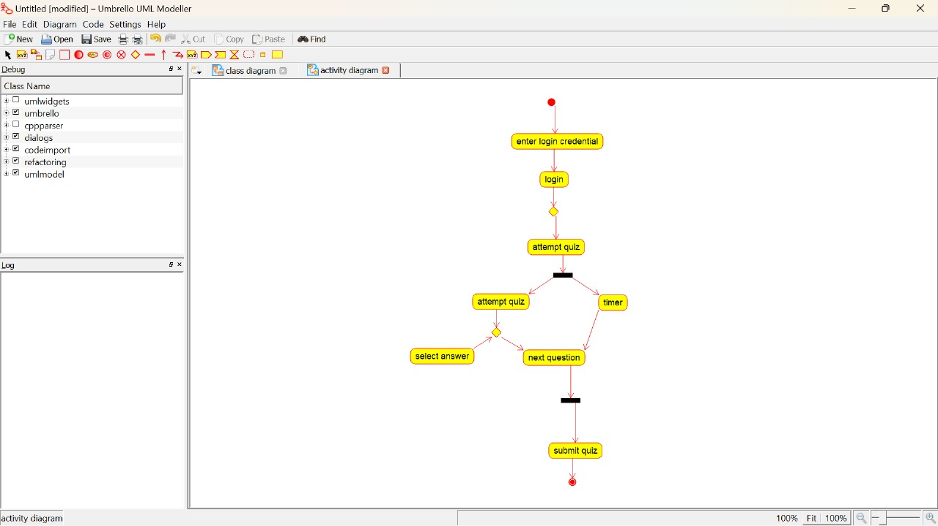

STATE DIAGRAM:
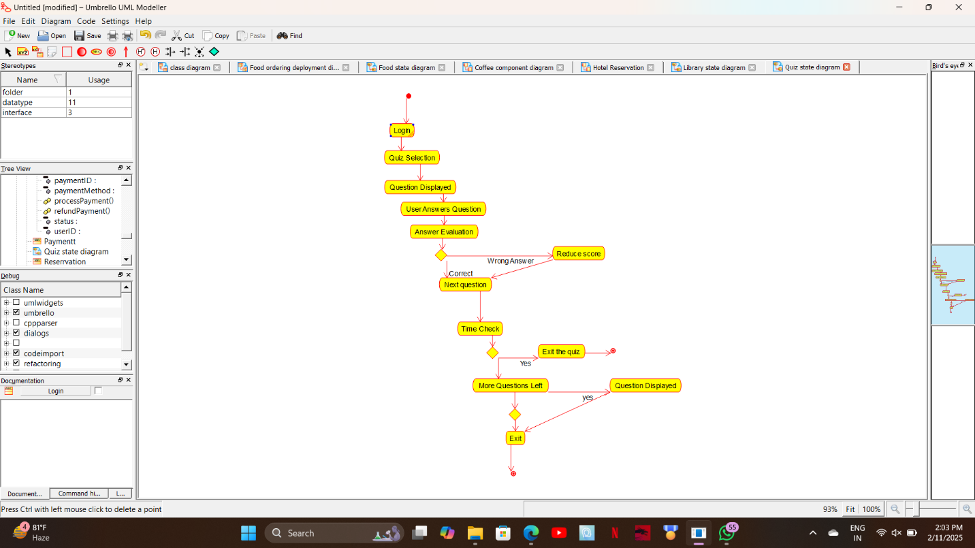

SEQUENCE DIAGRAM:
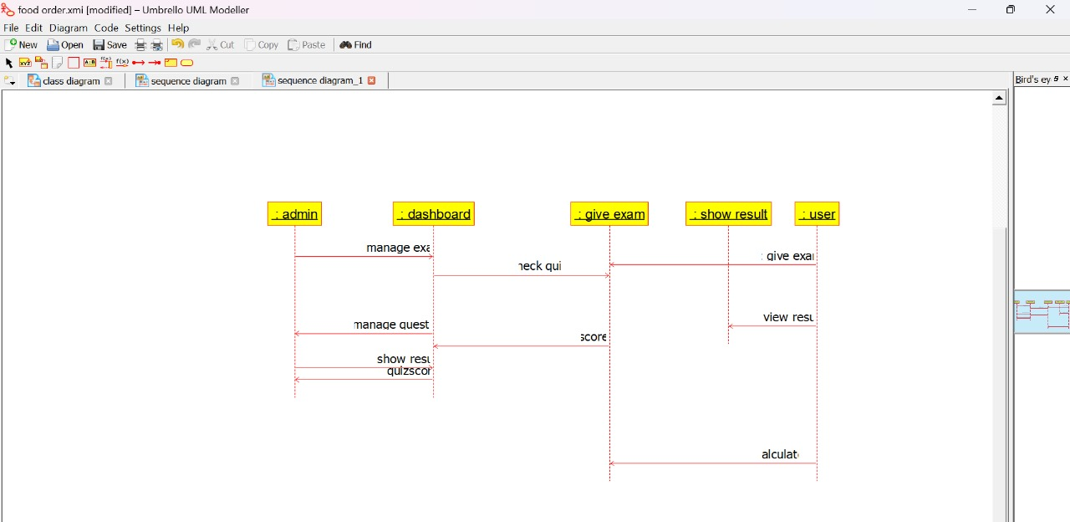

COMPONENT DIAGRAM:
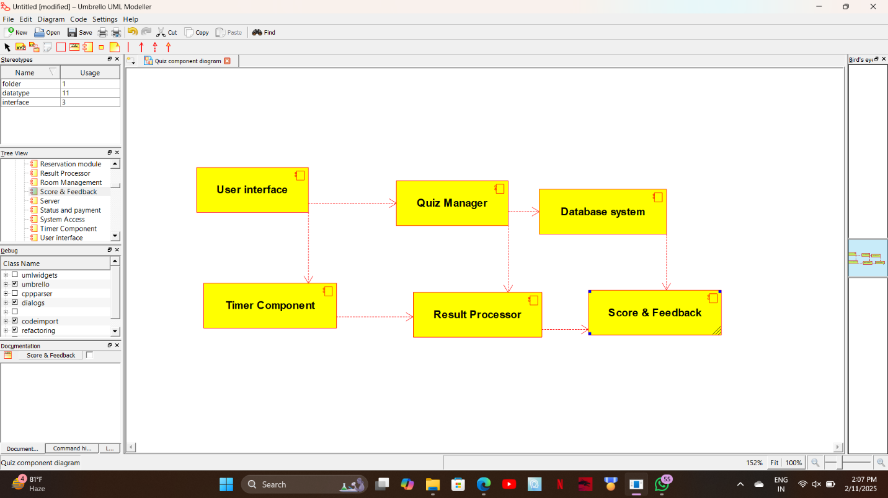

DEPLOYMENT DIAGRAM:
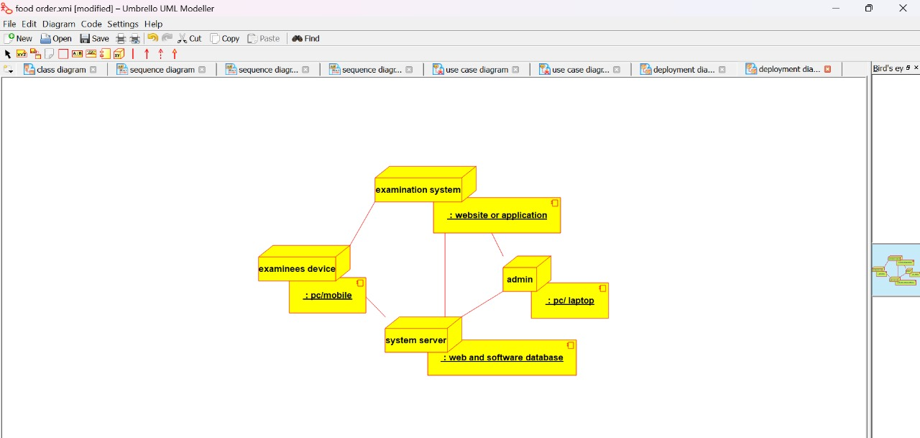

RESULT:

The UML Diagram for the Quiz System has been successfully created, representing the interactions between Users, Helpers, and Administrators with the system.

